**International Institute of Professional Studies**

**Devi Ahilya Vishvavidyalaya, Indore**



**M.Tech(IT) 5 Years VII Semester**

Project topic

“Weather Forecast Application”

**Link-** [**https://weather-abc.000webhostapp.com/**](https://weather-abc.000webhostapp.com/)

By

Shlok Majumdar (IT-2K18-50)

Vijay Borate (IT-2K18-56)

**Under the guidance of**

Dr. Vivek Shrivastava Sir

**DECLARATION**

I hereby declare that the project entitled “Weather Forecast Application” which is submitted by Shlok Majumdar and Vijay Borate as a minor project for Master of Technology(IT) 5 Years VII Semester to International Institute of Professional Studies, Devi Ahilya Vishwavidyalaya, Indore, comprises our own work and due acknowledgement has been made in text to all other material used.

Signature of Student:

Date:

Place: Indore

**CERTIFICATE FROM GUIDE**

It is to certify that dissertation on “Weather Forecast Application”, submitted by Shlok Majumdar and Vijay Borate to the International Institute of Professional Studies, DAVV, Indore has been completed under my supervision and the work is carried out and presented in a manner required for its acceptance in Master of Technology(IT) 5 Years VII Semester.

**Project Guide**

Signature:

**Name: Dr. Vivek Shrivastava Sir**

**Date:**

**CERTIFICATE**

It is to certify that we have examined the project on “Weather Forecast Application”, submitted by Shlok Majumdar and Vijay Borate to the International Institute of Professional Studies, DAVV, Indore and hereby accord our approval of it as a study carried out and presented in a manner required for its acceptance in Master of Technology(IT) 5 Years VII Semester.

**Internal Examiner External Examiner**

Signature**:** Signature**:**

Name  **:** Name **:**

Date **:** Date  **:**

ACKNOWLEDGEMENT

Every project big or small is successful largely due to the effort of a number of

wonderful people who have always given their valuable advice or lent a helping hand.

I sincerely appreciate the inspiration; support and guidance of all those people who have been instrumental in making this project a success. I Shlok Majumdar , Vijay Borate , the students of **IIPS M.Tech(**IT), are extremely grateful for the confidence bestowed in us and entrusting my project entitled **“Weather Forecast Application”**.

I feel deeply honored in expressing my sincere thanks to **Dr. Vivek Shrivastava Sir** for making the resources available at right time and providing valuable insights leading to the successful completion of my project.

I would also like to thank all the faculty members of **IIPS** for their critical advice and guidance without which this project would not have been possible. Last but not the least I place a deep sense of gratitude to our family members and our friends who have been constant source of inspiration during the preparation of this project work.

**DATE –    4 December, 2021**

**S.No. TABLE OF CONTENTS Page No.**

1. Introduction 8

2. Purpose 8

3. Scope 8

4. Software Development Life Cycle 9

5. Phases of Software Development Life Cycle 9

i) Requirement gathering phase (Identification Of Need) 9

ii) Feasibility Study 10

1. Technical feasibility(SRS) 11
2. Economic feasibility 11
3. Operational feasibility 12

iii) Analysis Phase 12

1. System Analysis 12

b) Technologies Used 13

c) Data Flow Diagram 14

iv) Design Phase 15

1. Basic Prototype 15

b) Working 16

v) User Interface and Coding Phase

A) User Interface screenshots 18

B) Coding Phase 22

a) index.html 22

b) index1.html 23

i) style.css 24

ii) app.js 27

c) index2.html 31

i) style1.css 35

ii) main.js 39

vi) Testing and Implementation 41

a) Introduction 41

b) Purpose 41

c) Objectives 41

d) Types of testing 42

i) Unit Testing 42

ii) Performance Testing 42

iii) Validation 42

iv) White Box Testing 42

v) Black Box Testing 43

vi) System Testing 43

vii) Output Testing 43

viii) User Acceptance Testing 44

e) Conclusion of testing and implementation 44

6. Software Model Used 46

7. Skills developed out of this project 47

8. Applications of this project 48

9. Bibliography 48

**Weather Forecast Application**

1. **Introduction**

Weather Forecast Application is a web based application through which you will able to get all the reports related to weather forecasting of any locations. It identifies the location and able to present the weather details such as temperature, minimum and maximum temperature, type, date, time etc. It also provides weather forecast of different days.

To change the location you will just have to type the city name in the search box.

1. **Purpose**

The purpose of developing weather app is to fetch the data in the need of taking information about weather worldwide. It helps to track weather forecasts and current conditions in real-time.

1. **Scope**

This weather forecast application has been made online so that it can be used currently as well as in future by a particular institute or organisation. Further it can be accessed and visited from different devices. The intention of developing weather app is to fetch the data in the need of taking information about the weather worldwide. This project is developed for windows, mac and android operating system.

1. **Software Development Life Cycle**

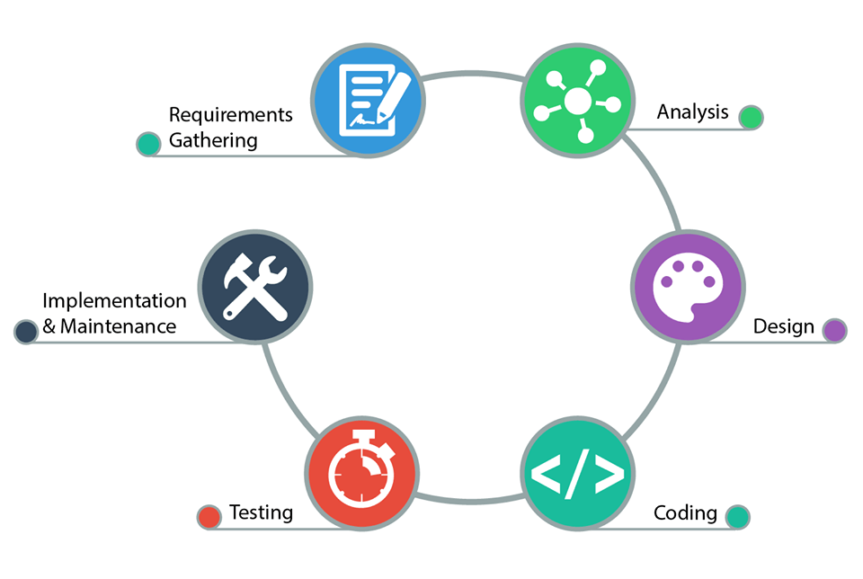

1. **Phases of Software Development Life Cycle**
2. **Requirement gathering phase(Identification Of Need)**

This is the first phase of our project development .In this phase we decide the topic of our project. The topic of our project is Weather Forecast Application. Our application would provide all the weather details related to the city we search. So we gather information about the technologies that we would use in our weather application. We also find system requirements and that are weather application would need.

1. **Feasibility Study:**

* Feasibility analysis begins once the goals are defined. It starts by generating broad possible solutions, which are possible to give an indication of what the new system should look like. This is where creativity and imagination are used. Analysts must think up new ways of doing things-generate new ideas.

* There is no need to go into the detailed system operation yet. The solution should provide enough information to make reasonable estimates about project cost and give users an indication of how the new system will fit into the organization. It is important not to exert considerable effort at this stage only to find out that the project is not worthwhile or that there is a need significantly change the original goal.

Feasibility of a new system means ensuring that the new system, which we are going to implement, is efficient and affordable.

There are various types of feasibility to be determined.

1. Technical feasibility
2. Economically feasibility
3. Operational feasibility

1. **Technical feasibility: Software Requirements Specification**

* The technical requirement for the system is economic and it does not use any other additional Hardware and software.

**Hardware and Software Requirements**

|  |  |  |
| --- | --- | --- |
| **S.No.** | **Name of Resource/Material** | **Specifications** |
| **1** | Hardware computer system | Computer above dual core, RAM minimum 2GB onwards but not limited to |
| **2** | Operating System | Windows XP,7,8,10,11,Mac,Android |
| **3** | Software | VS Code, Sublime Text |

1. **Economical Feasibility:**

* Development of this application is highly economically feasible.
* It is cost effective in the sense that has eliminated the paper work completely.
* The system is also time effective because the calculations are automated since we directly fetch data from OpenWeatherMap API as per the user requirement.

1. **Operational Feasibility:**

* The working of project is quite easy to use and learn due to its simple but attractive interface.
* User requires no special training for using this website.
* Weather app provides correct weather data according to the city searched by user and displays alert when user enters wrong city name.

1. **Analysis Phase**
2. **System Analysis:**

* Analysis can be defined as breaking up of any whole so as to find out their nature, function etc. It defines design as to make preliminary sketches of; to sketch a pattern or outline for plan.
* To plan and carry out especially by artistic arrangement or in a skilful way. System analysis and design can be characterized as a set of techniques and processes, a community of interests, a culture and an intellectual orientation.

In this phase we check that are application is practical or not. Our application would be practical since users can see the weather forecast of next 5 days and schedule their routine accordingly.

Then we decide the technologies that we would use in our project.

1. **Technologies Used**

In our project we use html, css , javascript , bootstrap, OpenWeatherMapAPI and 000webhost.

1. **HTML**

We use HTML to design the structure of our weather forecast app.

1. **CSS**

We use CSS for styling and formatting our weather app. We make our app more beautiful and attractive using CSS.

1. **JavaScript**

We use JavaScript to improve the functioning of our weather forecast app. We make use of various functions, events and properties to display weather information to the user.

1. **Bootstrap**

We use Bootstrap to make our application more responsive and interactive.

1. **OpenWeatherMapAPI**

We incorporate weather data from OpenWeatherMapAPI in our Weather Forecast Application. It is a very popular API which provides accurate and precise weather information.

1. **000webhost**

We used 000webhost to deploy our website online so that it can be accessed from different operating systems like windows, mac and android.

1. **Dataflow Diagram of Weather Forecasting Application**



1. **Design Phase**

Design phase is a very important phase. In design phase we design the basic prototype of our project so that coding can be done easily.

Here we plot our visual idea and make rough designs so that we can find some design errors and flaws.

1. **Basic Prototype**

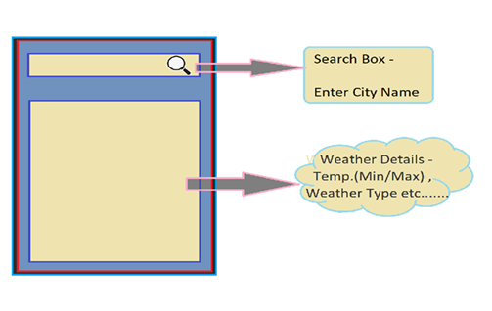

Back

Weather-Forecast

Our weather app contains a search box in which user can search the weather of any place. When user clicks enter all the information related to weather are displayed to the user like current temperature, date, time, minimum and maximum temperature, humidity and type of weather. User can also get the weather forecast of next 5 days by clicking on a button showing “**Weather-Forecast**”.

After clicking the button user just has to search city name and the forecast will be shown to the user in form of pictures with Min and Max Temperatures.

1. **Working -** Let us discuss the Project Prototype in Detail. We have used **HTML** - to make structure of app.

**CSS** -for styling it .

**JS** - to implement functionality**.**

**Bootstrap -** to make app responsive.

**000webhost -** to deploy the app online

At top we have a search box in which user can enter city name corresponding to which weather details is displayed at bottom of App.

Lets us Discuss one by one in detail –>

1. **Search Box -**

In this we will be using add **EventListner Function** of JS to handle Enter Key .The key code of Enter Key is = 13

So if ( event.keycode == 13 ) means Enter key is pressed

So then we will send the city entered by user to the

**getWeatherReport Function.**

**2)For Fetching Weather Details** **–**

to fetch the weather deatils from **OpenWeatherAPI** we have make use of ready made fetch function provided by **OpenWeatherAPI** which is

**Fetch Function. Fetch Function** takes 3 parameters –

* **WeatherAPI URL**
* **CITY Name(Will get from Search Box)**
* **Weather API Key**

**Example –** fetch('https://api.openweathermap.org/data/2.5/weather?id=' + cityID+ '&appid=' + key)

3)**Display Weather Details** -

For this we have made **showWeatherReport Function.**

It displays the City Name , Temperature , Min/MaxTemp ,

Date and Weather Type(such as Clear , Clouds, Haze , Mist , Smoke , Rain, Snow , Thunderstorm).

Our App also Display Weather Forecast Information to the

User -

* We have made a Button **Weather-Forecast ,** By clicking

On which user can detailed analysis of weather for next 5

Days. Details we get here is Min & Max Temp and

Weather Type (In form of Creative Cloud Images ) .

* We also have a back button clicking which will direct us to the first page of the project.

1. **User Interface and Coding Phase**

**A) User Interface (Screenshots)**

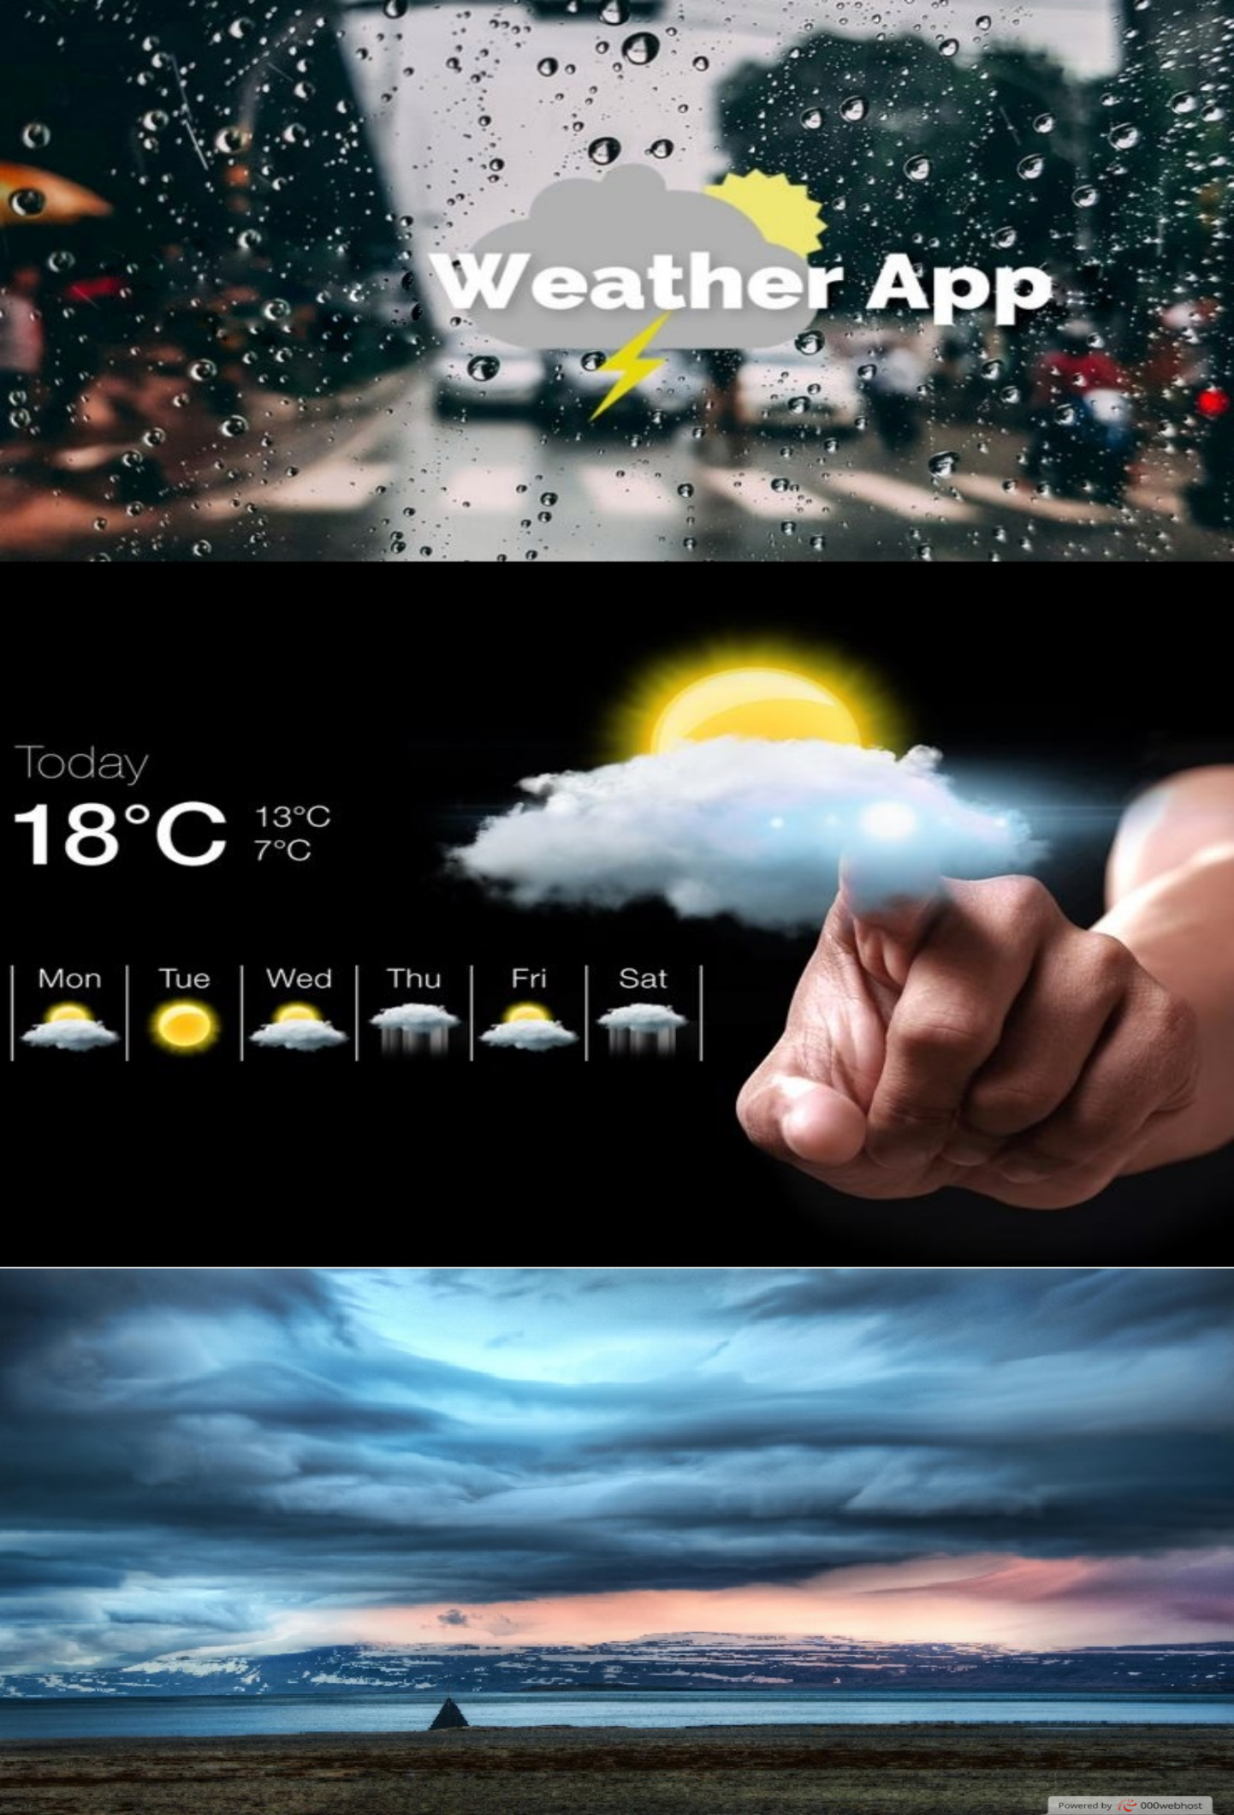

**index1.html**

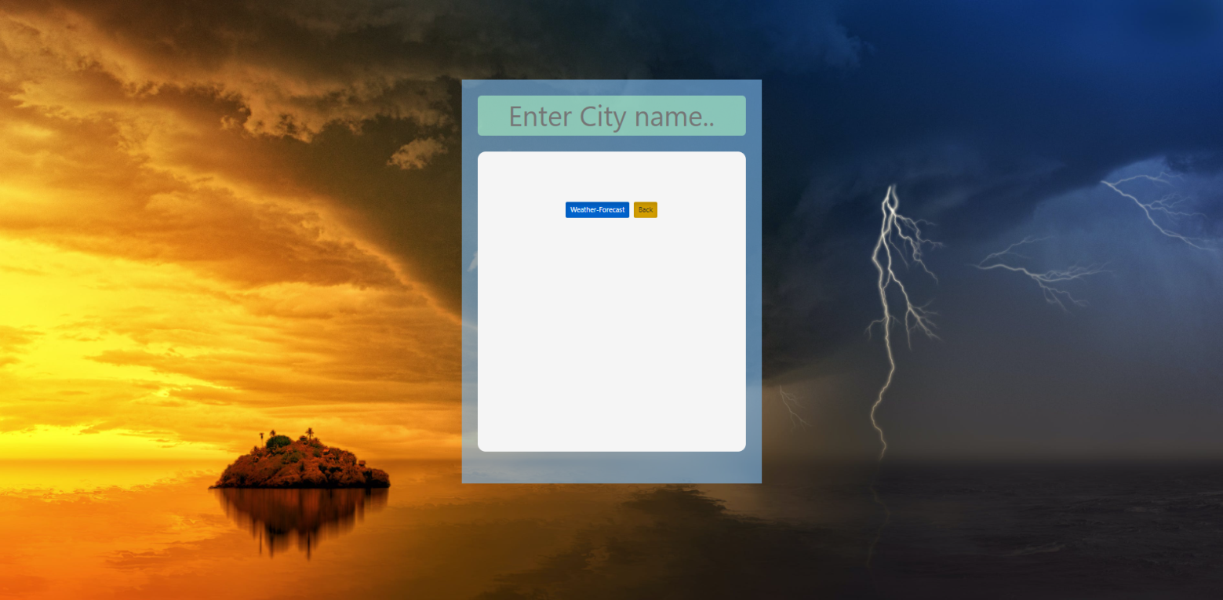

**index1.html**

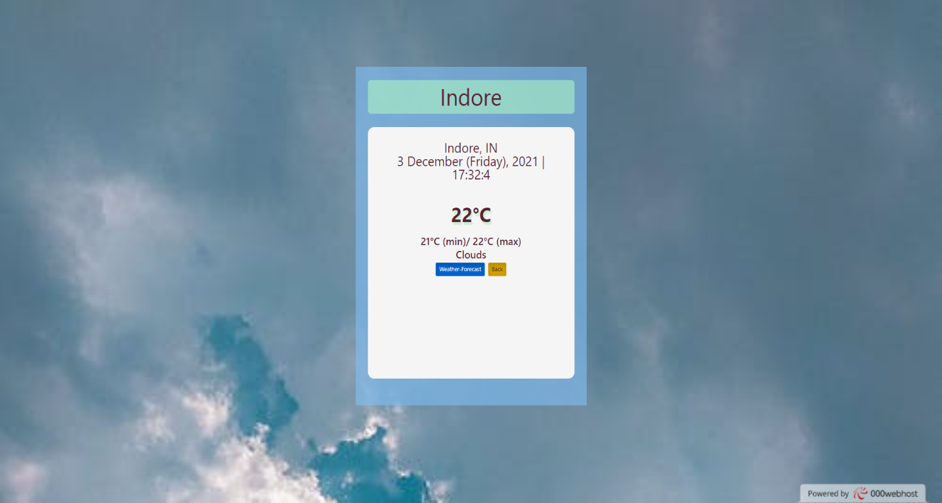

**index2.html**

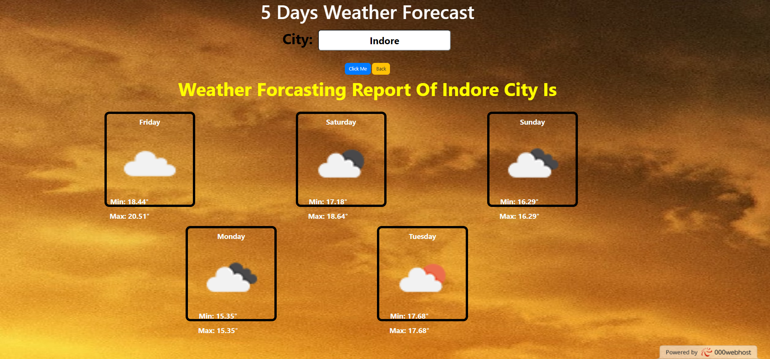

**index1.html**

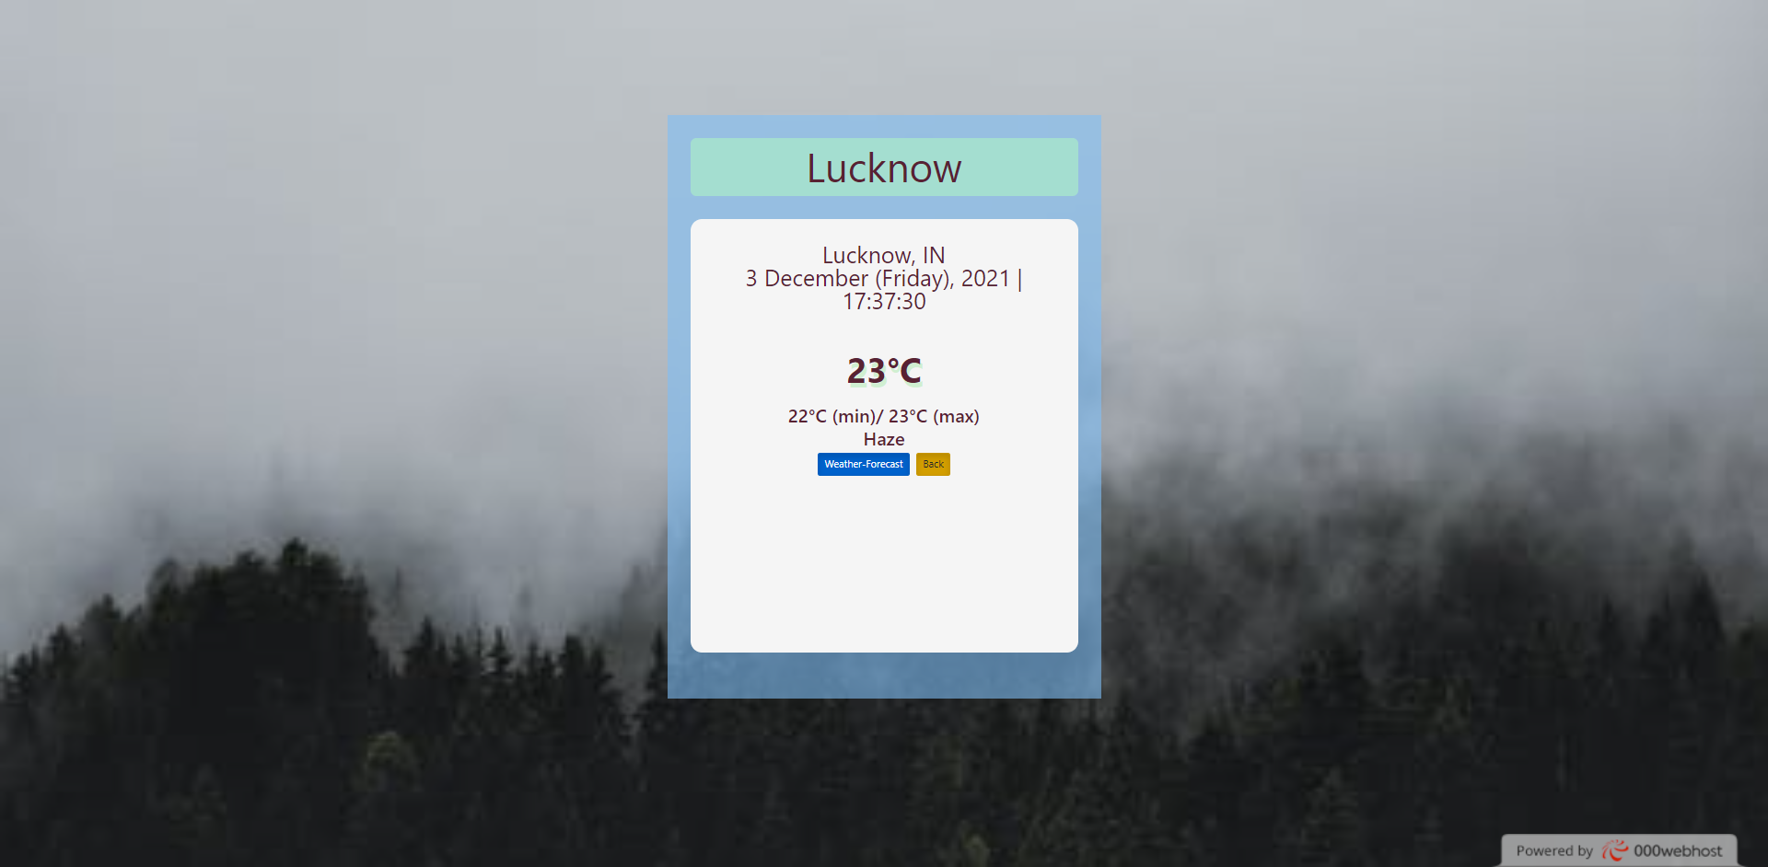

**index2.html**

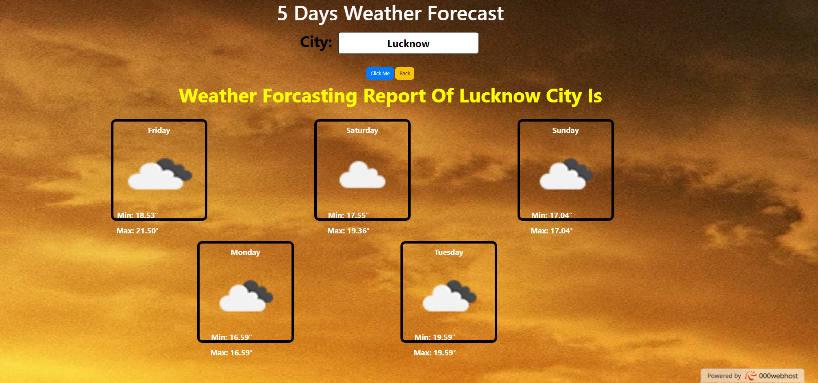

**index2.html**

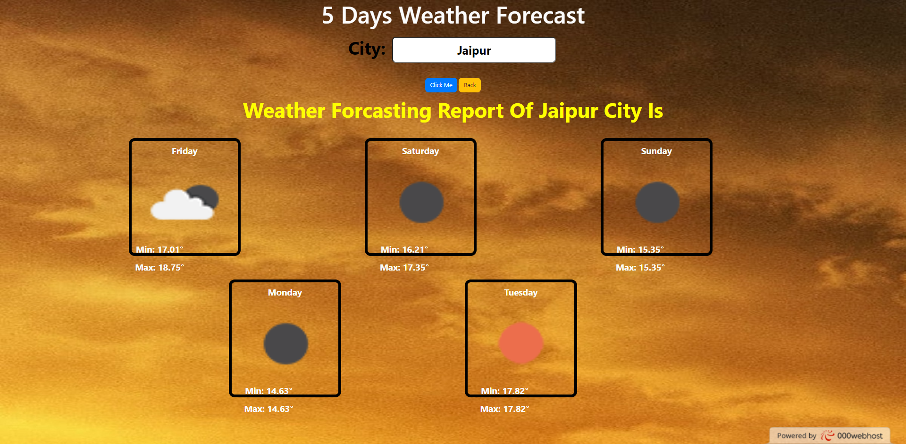

1. **B) Coding Phase**

In this phase we write the code for our weather forecasting application.

1. **index.html**

<!DOCTYPE html>

<html>

<head>

<link rel="stylesheet" href="https://maxcdn.bootstrapcdn.com/bootstrap/3.4.1/css/bootstrap.min.css">

<link rel="stylesheet" href="https://maxcdn.bootstrapcdn.com/bootstrap/4.0.0/css/bootstrap.min.css" integrity="sha384-Gn5384xqQ1aoWXA+058RXPxPg6fy4IWvTNh0E263XmFcJlSAwiGgFAW/dAiS6JXm" crossorigin="anonymous">

<link rel="stylesheet" href="https://maxcdn.bootstrapcdn.com/bootstrap/4.5.2/css/bootstrap.min.css">

</head>

<style>

responsive-image

{

width: 100%;

background-size: 100% 100%;

}

</style>

<body>

<a href="index1.html">

<img src="backimage.jpeg" width="121000" class="img-responsive img-fluid ">

</a>

</body>

</html>

1. **index1.html**

<!DOCTYPE html>

<html lang="en">

<head>

<meta charset="UTF-8">

<meta http-equiv="X-UA-Compatible" content="IE=edge">

<meta name="viewport" content="width=device-width, initial-scale=1.0">

<link rel="stylesheet" href="style.css">

<link rel="stylesheet" href="https://maxcdn.bootstrapcdn.com/bootstrap/3.4.1/css/bootstrap.min.css">

<link rel="stylesheet" href="https://maxcdn.bootstrapcdn.com/bootstrap/4.0.0/css/bootstrap.min.css" integrity="sha384-Gn5384xqQ1aoWXA+058RXPxPg6fy4IWvTNh0E263XmFcJlSAwiGgFAW/dAiS6JXm" crossorigin="anonymous">

<title>Weather App</title>

<style>

div.a:hover

{

-webkit-transform: scale(2,2);

}

div.b:hover

{

-webkit-transform: scale(1.4,1.4);

}

a.a:hover

{

-webkit-transform: scale(1.2,1.2);

}

</style>

</head>

<body background="backgroundimg.jpeg">

<div class="container-fluid">

<div class="app-main h-25">

<div class="searchInputBox">

<input type="text" id="input-box" class="input-box" style="font-size:35px" placeholder="Enter City name.."

autocomplete="off">

</div>

<div class="weather-body" style="font-size:20px">

<div class="">

<div class="d-none d-xl-block a " id="city"></div>

<div class="d-none d-xl-block b " id="date"></div>

</div>

<div class="weather-status">

<div class="temp a" style="font-size:30px" id="temp"> </div>

<div class="min-max d-none d-xl-block b" id="min-max"> </div>

<div class="weather d-none d-xl-block b " id="weather"></div>

<div class="img"></div>

<a href="index2.html" class="btn btn-primary btn-xs btn-sm btn-lg active a" role="button" aria-pressed="true">Weather-Forecast</a>

<a href="index.html" class="btn btn-warning btn-xs btn-sm btn-lg active a" role="button" aria-pressed="true">Back</a>

</div>

</div>

</div>

</div>

<script src="app.js"></script>

</body> </html>

**i) style.css**

*{

margin:0;

padding:0;

box-sizing: border-box;}

body{

background-image: url('backgroundimg.jpeg');

height:100vh;

overflow: hidden;

background-repeat: no-repeat;

/* background-position: top center;*/

font-family: Arial, Helvetica, sans-serif;

background-size:cover;

}

.app-main{

width:50vh;

margin:100px auto;

background-color: rgba(127, 190, 245, 0.6);

padding: 20px;

text-align: center;

}

.app-main >* {

margin-bottom: 20px;

}

.input-box{

width:100%;

background-color: rgba(174, 243, 197, 0.6);

border:none;

outline: none;

color:#582233;

font-size: 1.2rem;

height:50px;

border-radius: 5px;

padding:0 10px;

text-align:center;

}

.input-box:focus{

background-color: rgb(132, 248, 142);

}

.weather-body{

color:#582233;

padding:20px;

line-height: 2rem;

border-radius: 10px;

/*background-color: rgb(250, 250, 250)*/

background-color:whitesmoke;

height: 50vh;

}

.location-details{

font-weight: bold;

}

.weather-status{

padding:20px;

}

.temp{

font-size: 50pt;

font-weight: 700;

margin:20px 0;

text-shadow: 2px 4px rgba(121, 224, 126, 0.3);

}

.min-max , .weather{

font-size: 12pt;

font-weight: 600;

}

**ii) app.js**

const weatherApi = {

key: "7669c1b5c18b66347dc1108a04aa3cdb",

baseUrl:"https://api.openweathermap.org/data/2.5/weather"

}

const searchInputBox = document.getElementById('input-box');

// Event Listener Function on keypress

searchInputBox.addEventListener('keypress', (event) => {

if(event.keyCode == 13) {

console.log(searchInputBox.value);

getWeatherReport(searchInputBox.value);

document.querySelector('.weather-body').style.display = "block";

}

});

// Get Weather Report

function getWeatherReport(city) {

fetch(`${weatherApi.baseUrl}?q=${city}&appid=${weatherApi.key}&units=metric`)

.then(weather => {

return weather.json();

}).then(showWeatherReport);

}

// Show Weather Report

function showWeatherReport(weather){

try

{

console.log(weather);

let city = document.getElementById('city');

city.innerText = `${weather.name}, ${weather.sys.country}`;

let temperature = document.getElementById('temp');

temperature.innerHTML = `${Math.round(weather.main.temp)}&deg;C`;

let minMaxTemp = document.getElementById('min-max');

minMaxTemp.innerHTML = `${Math.floor(weather.main.temp_min)}&deg;C (min)/ ${Math.ceil(weather.main.temp_max)}&deg;C (max) `;

let weatherType = document.getElementById('weather');

weatherType.innerText = `${weather.weather[0].main}`;

let date = document.getElementById('date');

let todayDate = new Date();

date.innerText = dateManage(todayDate);

if(weatherType.textContent == 'Clear') {

document.body.style.backgroundImage = "url('images/clear.jpg')";

} else if(weatherType.textContent == 'Clouds') {

document.body.style.backgroundImage = "url('images/cloudy.jpeg')";

} else if(weatherType.textContent == 'Haze') {

document.body.style.backgroundImage = "url('images/fog.jpeg')";

} else if(weatherType.textContent == 'Mist') {

document.body.style.backgroundImage = "url('images/mist.jpeg')";

} else if(weatherType.textContent == 'Smoke') {

document.body.style.backgroundImage = "url('images/smoke.jpeg')";

} else if(weatherType.textContent == 'Rain') {

document.body.style.backgroundImage = "url('images/rain.jpeg')";

} else if(weatherType.textContent == 'Snow') {

document.body.style.backgroundImage = "url('images/snow.jpeg')";

} else if(weatherType.textContent == 'Thunderstorm') {

document.body.style.backgroundImage ="url('images/thunderstorm.jpeg')";

}

}

catch(err) {alert("ENTER CORRECT CITY NAME");}}

// Date manage

function dateManage(dateArg){

let days = ["Sunday", "Monday", "Tuesday", "Wednesday", "Thursday", "Friday", "Saturday"];

let months = ["January", "February", "March", "April", "May", "June", "July", "August", "September", "October", "November", "December"];

let year = dateArg.getFullYear();

let month = months[dateArg.getMonth()];

let date = dateArg.getDate();

let day = days[dateArg.getDay()];

let hr = dateArg.getHours();

let min = dateArg.getMinutes();

let sec = dateArg.getSeconds();

return `${date} ${month} (${day}), ${year} | ${hr}:${min}:${sec}`;}

**c) index2.html**

<!DOCTYPE html>

<html lang="en">

<head>

<meta charset="UTF-8">

<meta http-equiv="X-UA-Compatible" content="IE=edge">

<meta name="viewport" content="width=device-width, initial-scale=1.0">

<link rel="stylesheet" href="style1.css">

<link rel="stylesheet" href="https://maxcdn.bootstrapcdn.com/bootstrap/3.4.1/css/bootstrap.min.css">

<link rel="stylesheet" href="https://maxcdn.bootstrapcdn.com/bootstrap/4.0.0/css/bootstrap.min.css" integrity="sha384-Gn5384xqQ1aoWXA+058RXPxPg6fy4IWvTNh0E263XmFcJlSAwiGgFAW/dAiS6JXm" crossorigin="anonymous">

<link rel="stylesheet" href="https://maxcdn.bootstrapcdn.com/bootstrap/4.5.2/css/bootstrap.min.css">

<script src="https://maxcdn.bootstrapcdn.com/bootstrap/4.5.2/js/bootstrap.min.js"></script>

<title>Document</title>

<style>

body {

background-image: url('backgroundimg.jpeg');

background-size: cover;

background-repeat: no-repeat;

background-size: 500% 500%;

}

h1.a:hover

{

-webkit-transform: scale(1.2,1.2);

}

h2.a:hover

{

-webkit-transform: scale(1.1,1.1);

}

button.a:hover

{

-webkit-transform: scale(1.2,1.2);

}

div.a:hover

{

-webkit-transform: scale(1.2,1.2);

}

</style>

</head>

<body onload="DefaultScreen()">

<center>

<h1 id="Para1" class="a "style="font-size:40px;color:rgb(252, 252, 252);">5 Days Weather Forecast</h1>

<p id="inputContainer" style="font-size:30px;color:rgb(0, 0, 0);">City: <input type="text" id="cityInput" style="border-radius: 6px"></p><BR>

<button type="button" class="btn btn-primary a" onclick="GetInfo()" style="border-radius: 6px ;">Click Me</button>

<button type="button" class="btn btn-warning a" onclick="window.location.href = 'index1.html';" style="border-radius: 6px ;">Back</button>

<h2 id="cityName" class="a d-none d-xl-block"></h2>

</center>

<div class="container" id = "weatherContainer iconsContainer">

<div class="row">

<div class = "icons d-none d-xl-block a">

<p class="weather" id="day1" style="font-size:15px ;color:rgb(250, 252, 249);font-weight:bolder;"></p>

<div class="image"><img src="dots.png" class="imgClass" id="img1"></div>

<p class="minValues" id="day1Min" style="font-size:15px ;color:rgb(250, 252, 249);font-weight:bolder;">Loading...</p>

<p class="maxValues" id="day1Max" style="font-size:15px ;color:rgb(250, 252, 249);font-weight:bolder;">Loading...</p>

</div>

<div class = "icons col-xs-2 offset-md-2 a" >

<p class="weather" id="day2" style="font-size:15px ;color:rgb(250, 252, 249);font-weight:bolder;"></p>

<div class="image"><img src="dots.png" class="imgClass" id="img2"></div>

<p class="minValues" id="day2Min" style="font-size:15px ;color:rgb(250, 252, 249);font-weight:bolder;">Loading...</p>

<p class="maxValues" id="day2Max" style="font-size:15px ;color:rgb(250, 252, 249);font-weight:bolder;">Loading...</p>

</div>

<div class = "icons col-xs-2 offset-md-2 a">

<p class="weather" id="day3" style="font-size:15px ;color:rgb(250, 252, 249);font-weight:bolder;"></p>

<div class="image"><img src="dots.png" class="imgClass" id="img3"></div>

<p class="minValues" id="day3Min" style="font-size:15px ;color:rgb(250, 252, 249);font-weight:bolder;">Loading...</p>

<p class="maxValues" id="day3Max" style="font-size:15px ;color:rgb(250, 252, 249);font-weight:bolder;">Loading...</p>

</div>

<div class = "icons col-xs-2 offset-md-2 a">

<p class="weather" id="day4" style="font-size:15px ;color:rgb(250, 252, 249);font-weight:bolder;"></p>

<div class="image"><img src="dots.png" class="imgClass" id="img4"></div>

<p class="minValues" id="day4Min" style="font-size:15px ;color:rgb(250, 252, 249);font-weight:bolder;">Loading...</p>

<p class="maxValues" id="day4Max" style="font-size:15px ;color:rgb(250, 252, 249);font-weight:bolder;">Loading...</p>

</div>

<div class = "icons col-xs-2 offset-md-2 a">

<p class="weather" id="day5" style="font-size:15px ;color:rgb(250, 252, 249);font-weight:bolder;"></p>

<div class="image"><img src="dots.png" class="imgClass" id="img5"></div>

<p class="minValues" id="day5Min" style="font-size:15px ;color:rgb(250, 252, 249);font-weight:bolder;">Loading...</p>

<p class="maxValues" id="day5Max" style="font-size:15px ;color:rgb(250, 252, 249);font-weight:bolder;">Loading...</p>

</div>

</div>

</div>

<script src="main.js"></script>

</body>

</html>

**i) style1.css**

*{

font-family: 'Segoe UI', Tahoma, Geneva, Verdana, sans-serif;

}

body{

background-image: url('sky.jpg');

background-size: cover;

background-repeat: no-repeat;

}

#cityInput, #cityName, #inputContainer,button{

margin: 3px;

padding:5px;

text-align:center;

font-size:20px;

font-weight:bold;

}

#weatherContainer{

position: absolute;

top: 70%;

left: 50%;

margin-right: -50%;

transform: translate(-50%, -50%);

height: 300px;

width: 1300px;

border-radius: 10px;

}

#iconsContainer{

position: absolute;

top: 50%;

left: 50%;

margin-right: -50%;

transform: translate(-50%, -50%);

height: 240px;

width: 1200px;

border-radius: 10px;

}

.icons{

display: inline-bock;

float: left;

height: 200px;

width: 190px;

margin: 20px;

border: 5px solid rgb(48, 47, 47);

border-radius: 10px;

}

.image{

height: 140px;

width: 100%;

}

.imgClass{

height: 140px;

width: 100%;

}

.weather{

margin: 5px;

border-radius: 5px;

text-align: center;

font-weight: bold;

}

.minValues{

text-align: center;

display: inline-block;

border-radius: 5px;

height: 25px;

width: 85px;

margin: 0;

margin-bottom: 5px;

margin-left: 5px;

}

.maxValues{

text-align: center;

display: inline-block;

border-radius: 5px;

height: 25px;

width: 85px;

margin: 0;

margin-bottom: 5px;

margin-left: 5px;

}

**ii) main.js**

function GetInfo() {

var newName = document.getElementById("cityInput");

var cityName = document.getElementById("cityName");

cityName.innerHTML = "Weather Forcasting Report Of "+newName.value+" City Is";

cityName.style.fontSize='35px'

cityName.style.color='yellow';

fetch('https://api.openweathermap.org/data/2.5/forecast?q='+newName.value+'&appid=32ba0bfed592484379e51106cef3f204')

.then(response => response.json())

.then(data => {

//Getting the min and max values for each day

for(i = 0; i<5; i++){

document.getElementById("day" + (i+1) + "Min").innerHTML = "Min: " + Number((data.list[i].main.temp_min)-273.15).toFixed(2)+ "°";

//Number(1.3450001).toFixed(2); // 1.35 - 273.15

}

for(i = 0; i<5; i++){

document.getElementById("day" + (i+1) + "Max").innerHTML = "Max: " + Number((data.list[i].main.temp_max) - 273.15).toFixed(2) + "°";

}

//Getting Weather Icons

for(i = 0; i<5; i++){

document.getElementById("img" + (i+1)).src = "http://openweathermap.org/img/wn/"+

data.list[i].weather[0].icon

+".png";

}

console.log(data)

})

.catch(err => alert("Something Went Wrong: Try Checking Your Internet Connection"))

}

function DefaultScreen(){

document.getElementById("cityInput").defaultValue = "Indore";

GetInfo();

}

//Getting and displaying the text for the upcoming five days of the week

var d = new Date();

var weekday = ["Sunday", "Monday", "Tuesday", "Wednesday", "Thursday", "Friday", "Saturday",];

//Function to get the correct integer for the index of the days array

function CheckDay(day){

if(day + d.getDay() > 6){

return day + d.getDay() - 7;

}

else{

return day + d.getDay();

}

}

for(i = 0; i<5; i++){

document.getElementById("day" + (i+1)).innerHTML = weekday[CheckDay(i)];

}

1. **Testing and Implementation Phase**
2. **Introduction**

Testing is the process of running a system with the intention of finding errors. Testing enhances the integrity of a system by detecting deviations in design and errors in the system. Testing aims at detecting error-prone areas. This helps in the prevention of errors in a system. Testing also adds value to the product by conforming to the user requirements.

1. **Purpose**

The main purpose of testing is to detect errors and error prone areas in a system. Testing must be through well planned.

A partially tested system is to detect errors and error prone areas in a system. Testing must be through well planned.

A partially tested system is as bad as an untested system.

1. **Objectives of Testing**

The objective our test plan is to find and report as many bugs as possible to improve the integrity of our project.

Our user interface to utilize these functions is designed to be user-friendly and provide easy manipulation of the tree.

The application will only be used as a demonstration tool, but we would like to ensure that it could be run from a variety

of platforms with little impact on performance or usability.

1. **Types of Testing in our Weather Forecast Application**
2. **Unit Testing**

Unit testing focuses verification effort on the smallest unit of software design- the software component or module.

The unit test is white-box oriented. The unit testing implemented in every module of Weather Application.

By giving correct manual input to the system we fetched the weather data from OpenWeatherMap API. We did not encounter any error in the output and got the correct output everytime.

1. **Performance Testing**

Performance testing is designed to test the run-time performance of software within the context of an integrated system.

Performance testing occurs throughout all steps in the testing process. Our Weather Application Project will display results fast. We don’t have to wait extra time for results. When we click enter the correct result will be displayed in few milliseconds. The application used only low memory of our system and it automatically did not get access to any software.

1. **Validation**

Validation testing can be defined in many ways, but a simple definition is that the validation succeeds when the software functions in a manner that is expected by the customer.

1. **White Box Testing**

In white box testing, we made the UI functional using bootstrap. Inputs and outputs are tested directly at the code level and the results are compared against specifications. This form of testing ignores the function of the program under test and will focus only on its code and the structure of that code. Because the functionality of the program is relatively simple, this method will be feasible to apply.

1. **Black Box Testing**

We performed **Black box testing** which typically involves running through every possible input to verify that it results in the right output using the software as an end-user would.

We searched for weather of many cities in our project as test case and each of the test cases would provide current weather details as well as the weather forecast of the next 5 days.

1. **System Testing**

Generally, system testing is mainly concerned with areas such as performance, security, validation, load/stress, and configuration sensitivity.

1. **Output Testing**

Finally we ensured that our weather forecast application is working with the help of Output testing. Output testing of the proposed system is needed, since no system could be useful if it does not produce the required output in a specific format.

The output format on the screen is found to be correct and responsive by using bootstrap. The format was designed in the system design time according to the user needs. For the hardcopy also; the output comes as per the specified requirements by the user.

Hence output testing did not result in any correction for the system.

1. **User Acceptance Testing**

User acceptance of a system is the key factor for the success of any system. The system under consideration is tested for the user acceptance by constantly keeping in touch with the prospective system users at the time of developing and making changes whenever required. We have tested this app with our family members and relatives.

1. **Conclusion of Testing and Implementation**

* We ensured that we get the right weather information for the right input city. We tested the application for various inputs and got correct output.
* We ensured that our Weather Forecast Application is responsive and can adapt according to the varying screen sizes.
* We also ensured that our app can run on different environments like windows, android and mac.

**6. Software Model Used**

* **Agile Model**  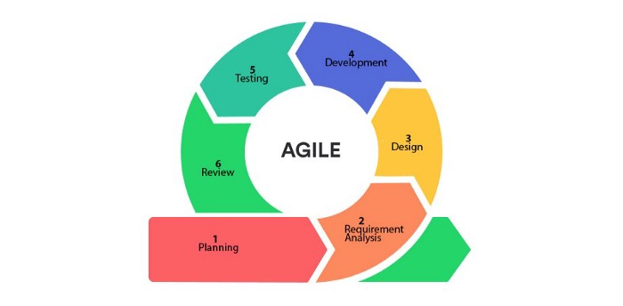
* Agile SDLC model is a combination of iterative and incremental process models focusing on process adaptability and customer satisfaction by rapid delivery of working software products.
* Agile Methods break the product into small incremental builds. These builds are provided in iterations. Each iteration typically lasts from about one to three weeks. Every iteration involves cross-functional teams working simultaneously on various areas like
* Planning
* Requirements Analysis
* Design
* Development
* Unit Testing and
* Acceptance Testing

Advantages of the Agile Model

* This makes sure that the client is continuously involved during every stage.
* Agile teams are incredibly motivated and self-organized, so it likely to provide better results from the development projects.
* The agile software development method assures that quality of the development is maintained.
* The process is entirely based on incremental progress step by step. Therefore, the client and team know exactly what is completed and what is not.
* Reduces the risk in the development process.

**7.Skills developed out of this project.**

1. Develop a JavaScript Program using different concepts

2. Able to debug and run a Javascript Program

3. Documentation of Project

4. Time management

5. Technical Writing

6. Team work

7. Problem solving

**8.Applications of this Project**

1. Websites

2. Web application

3. Information

**9.Bibliography**

1. Base url to fetch current weather data from OpenWeatherMapAPI (app.js)

<https://api.openweathermap.org/data/2.5/weather>

1. Key to fetch current weather data from OpenWeatherMapAPI

7669c1b5c18b66347dc1108a04aa3cdb (app.js)

1. Base url to fetch weather forecast of 5 days from OpenWeatherMapAPI (main.js)

<https://api.openweathermap.org/data/2.5/forecast?q=>

1. Key to fetch weather forecast of 5 days from OpenWeatherMapAPI (main.js)

32ba0bfed592484379e51106cef3f204

1. For applying different CSS(style.css and style1.css)

<https://www.w3schools.com/css/>

6.Used JS to make app functional

<https://www.w3schools.com/js/>

7.Used 000webhost to deploy application online

<https://www.w3schools.com/js/>

8.Documentation to make our website more responsive

Using bootstrap(index.html, index1.html, index2.html)

<https://getbootstrap.com/docs/4.0/getting-started/introduction/>